Choose a Level | WriteShop Junior

WriteShop Junior is a parent-directed writing curriculum for children in grades 3-6. This placement guide will help you choose the best starting level for your child.

Caution: Don’t Choose a Level That’s Too Young

Each WriteShop Junior level teaches specific skills within a range of ages, making it easier to choose the very best place to begin the program. However, age and skill are not the only factors. Your child’s reasoning skills, emotional maturity, and ability to express ideas orally are also important considerations. So before you decide on a level, make sure to look at the big picture!

Start at the level that best fits your student’s thinking skills, not his writing skills. A child’s ability to physically write things down often lags behind his intellect and vocabulary. Some 4th and 5th graders still have a hard time putting pencil to paper. If you have a child like this, resist the temptation to start him in WriteShop Primary. Placing him in a level that feels “beneath him” socially and emotionally can jeopardize his willingness to write.
WriteShop Junior is a better fit for most upper-elementary students—even if they haven’t had much writing experience. Here’s why:
- Key concepts carry over into future books, so don’t worry about having “missed” something. All important concepts are carried over to future books, where they will be reintroduced and practiced.
- Smaller Steps and Flying Higher activities appear in all Primary and Junior books, allowing you to adjust assignments to the child’s level of ability.

WriteShop Junior Book D

Target: 3rd & 4th grade (or reluctant 5th)
- Most children who have completed WriteShop Primary Book B or Book C can move right into Book D.
- Book D makes a good choice for first-time WriteShop students who have weak sentence or paragraph skills. (Reluctant writers are encouraged to do some or all of the work orally; however, extremely reluctant 3rd graders may gain more confidence starting with WriteShop Primary Book C.)
- 6th and 7th graders with special needs may also find success with Book D—as long as they are not put off by the more juvenile worksheet illustrations.
Start with Book D if your 8- to 11-year-old needs to learn how to:
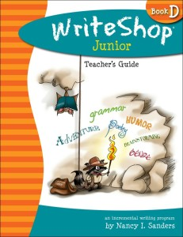
- Identify and use proper grammar and punctuation
- Identify and correctly use parts of speech
- Narrow a broad topic to a specific topic
- Brainstorm before writing
- Write an adequate sentence
- Write a basic paragraph
- Choose strong words instead of weak ones
- Use editing tools to correct and revise compositions
If your child is already somewhat confident in most of these areas, consider choosing Book E instead.

WriteShop Junior Book E

Target: 4th & 5th grade (or reluctant 6th)
- Use Book E with upper-elementary children who have already learned basic sentence and paragraph skills.
- 5-paragraph writing is introduced about 2/3 of the way through the book. If you anticipate your child’s readiness to learn this skill by then, Book E should be a good fit. However, even when a child is not quite ready to write five paragraphs, “Smaller Steps” activities will always give simpler options.
- 7th and 8th graders with special needs (or who haven’t had much formal writing instruction) may also find success with Book E—as long as they are not put off by the simplicity of the Activity Pack artwork.
Start with Book E if your 9- to 12-year-old needs to learn how to:
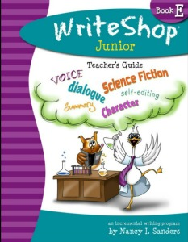
- Choose a point of view
- Develop the middle of the story to make it interesting
- Develop voice and show emotion in his writing
- Vary sentence length
- Write a book summary
- Write an expository nonfiction report
- Write a 5-paragraph composition
If the younger artwork will bother a more mature 11- or 12-year-old, consider choosing WriteShop I instead.

